**International Conference on Quran as Foundation of Civilization**

**(SWAT 2025)**

**(Title: Font Times New Roman, Size 14, Bold, UPPERCASE, Centre Aligment, Line & Spacing 1.0)**

First Author i, Second Author ii, Third Author iii

**(Author: Font Times New Roman, Size 12, Capitalize Each Word, Centre Aligment, Line & Spacing 1.0)**

i (Corresponding author). Senior Lecturer, Faculty of Quranic and Sunnah Studies, Universiti Sains Islam Malaysia. Email: [xxxx@usim.edu.my](mailto:xxxx@usim.edu.my)

ii Designation, Institution. email@email.com

iii Designation, Institution. email@email.com

ABSTRACT

**(Abstract: Font Times New Roman, Size 12, Bold, UPPERCASE, Centre Alignment)**

Abstract should not be more than 300 words. Abstract should include a brief statement on the issue(s) and problem that prompted the inception of the research or writing of this paper, the aim of the research or paper as well as the methodology used to collect and analysed the data obtained. A short statement of the implication of findings and/or expected findings can conclude the abstract. **(Abstract: Font Times New Roman, Size 12, Justify, Line & Spacing 1.0)**

**Keywords:** keyword1, keyword2, keyword3

(Keywords arrange in alphabetically order and not more than five keywords)

**INTRODUCTION**

**(Topic: Font Times New Roman,** **Size 12, Bold, UPPERCASE, Justify)**

In this paper, the formatting requirements for the **International Conference on Quran as Foundation of Civilization (SWAT 2025)** are described. Some recommendations on writing for a worldwide readership are offered. Please review this document to learn about the formatting of text, table captions, references, and the method to include the indexing information. The conference proceedings will be published in an electronic format. The full paper in MS Word file shall be written in compliance with these instructions.

This format is to be used for submissions that are published in the e-proceeding. We wish to give this journal a consistent, high-quality appearance. We therefore ask that authors follow some simple guidelines. In essence, you should format your paper exactly like this document. The easiest way to do this is simply to download a template from the conference web site and replace the content with your own material.

Authors are requested to submit the Full paper (**maximum of 15 pages in the length**) in electronic form (MS-Word) via ConfBay. Authors are responsible in proofreading their own papers. The conference secretariat is not responsible for any editing work for the paper. Papers with extensive errors (grammar and spelling) will be returned to authors without review.

After the conference, selected submissions will be invited to be extended and/or revised into articles for publishing in MyCite indexed journals (with additional fees).

# LITERATURE REVIEW / TOPIC 1

**(Topic: Font Times New Roman, Size 12, Bold, UPPERCASE, Justify)**

The uniform appearance will assist the reader to read the paper of the proceedings. It is therefore suggested to authors to use the example of this file to construct their papers. This example uses an American letter format with 25 mm margins left, right, top and bottom.

All text paragraphs should be single spaced. Position and style of headings and subheadings should follow this example. No spaces should be placed between paragraphs.

**(Subtopic: Font Times New Roman, Size 12, Bold, Capitalize Each Word, Justify)**

**Fonts**

Papers should use **12-point Times New Roman font**. The styles available are bold, italic and underlined.

**Tables and Figures**

Figure captions and table headings should be sufficient to explain the figure or table without needing to refer to the text.

It is recommended that text in table use Times New Roman font size 10 in centre alignment. For table heading should be in above the table and centre. For design table, should use Plain Table 2 and Bold the header. The following is an example for Table 1.

Table 1: Title of Example Table

|  |  |  |
| --- | --- | --- |
| Date | Title | Descriptions |
| 2 January 2020 | x | x |
| 5 February 2020 | x | x |

Meanwhile, the text in figure use Times New Roman font size 10 in centre alignment. For figure heading should be in below the table and centre. The following is an example for Figure 1.

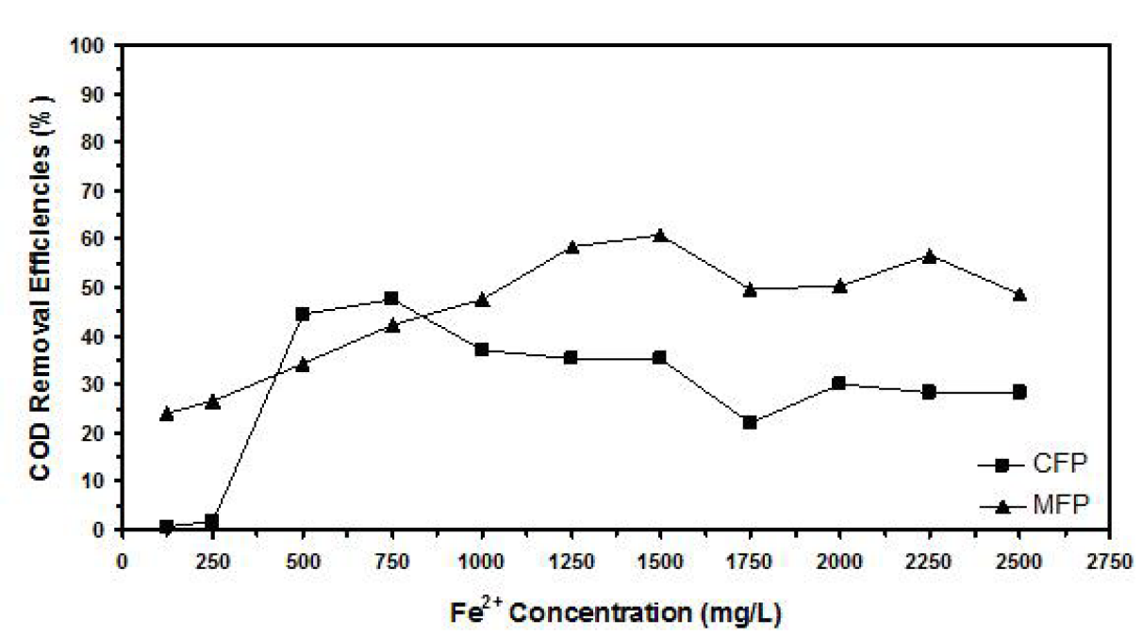

Figure 1: Example of figure for the extended abstract.

# METHODOLOGY / TOPIC 2

After the text edit has been completed, the paper is ready for the template. Duplicate the template file by using the Save As command and use the naming convention prescribed by your conference for the name of your paper. In this newly created file, highlight all the contents and import your prepared text file. You are now ready to style your paper; use the scroll down window on the left of the MS Word Formatting toolbar.

# FINDING & DISCUSSION / TOPIC 3

The finding must be clear in writing and should be discussed thoroughly and proven with correct citation.

# CONCLUSION

Conclusions should state concisely the most important propositions of the paper as well as the author’s views of the practical implications of the results.

**ACKNOWLEDGMENT (If any):**

The authors would like to express their appreciation for the support of the sponsors with Project No xxxx or acknowledgement to research grant where appropriate.

# REFERENCES

**(References: Font Times New Roman, Size 12, Justify, Line & Spacing 1.0)**

Please use **APA 7th referencing style**, alphabetize by author and for each author list in chronological sequence. Please refer to this link for details. <https://owl.purdue.edu/owl/research_and_citation/apa_style/apa_formatting_and_style_guide/index.html> Please do NOT list references as footnotes at the end of each page.

**Single author**

*Last name first, followed by author initials*.

Ahmed, S. (2012). *On being included: Racism and diversity in institutional life*. Duke University Press.

**Two authors**

*List by their last names and initials. Separate author names with a comma. Use the ampersand instead of "and."*

Soto, C. J., & John, O. P. (2017). The next big five inventory (BFI-2): Developing and assessing a hierarchical model with 15 facets to enhance bandwidth, fidelity, and predictive power. *Journal of Personality and Social Psychology*, *113*(1), 117-143. <http://dx.doi.org/10.1037/pspp0000096>

**Three to twenty authors**

*List by last names and initials; commas separate author names, while the last author name is preceded again by ampersand*.

Nguyen, T., Carnevale, J. J., Scholer, A. A., Miele, D. B., & Fujita, K. (2019). Metamotivational knowledge of the role of high-level and low-level construal in goal-relevant task performance. *Journal of Personality and Social Psychology, 117*(5), 879-899. http://dx.doi.org/10.1037/pspa0000166

**More than twenty authors**

*List by last names and initials; commas separate author names. After the first 19 authors’ names, use an ellipsis in place of the remaining author names. Then, end with the final author's name (do not place an ampersand before it). There should be no more than twenty names in the citation in total.*

Pegion, K., Kirtman, B. P., Becker, E., Collins, D. C., LaJoie, E., Burgman, R., Bell, R., DelSole, R., Min, D., Zhu, Y., Li, W., Sinsky, E., Guan, H., Gottschalck, J., Metzger, E. J., Barton, N. P., Achuthavarier, D., Marshak, J., Koster, R., . . .  Kim, H. (2019). The subseasonal experiment (SubX): A multimodel subseasonal prediction experiment. *Bulletin of the American Meteorological Society*, *100*(10), 2043-2061. https://doi.org/10.1175/BAMS-D-18-0270.1

**Article in print journal**

Scruton, R. (1996). The eclipse of listening. *The New Criterion, 15*(3), 5–13.

**Article in electronic journal**

*When citing an article in an electronic journal, include a DOI if one is associated with the article.*

Baniya, S., & Weech, S. (2019). Data and experience design: Negotiating community-oriented digital research with service-learning. *Purdue Journal of Service-Learning and International Engagement*,*6*(1), 11–16. https://doi.org/10.5703/1288284316979

*DOIs may not always be available. In these cases, use a URL. Many academic journals provide stable URLs that function similarly to DOIs. These are preferable to ordinary URLs copied and pasted from the browser's address bar.*

Denny, H., Nordlof, J., & Salem, L. (2018). "Tell me exactly what it was that I was doing that was so bad": Understanding the needs and expectations of working-class students in writing centers. *Writing Center Journal*,*37*(1), 67–98. https://www.jstor.org/stable/26537363

**Books**

Stoneman, R. (2008). *Alexander the Great: A life in legend*. Yale University Press.

**APPENDIX (if any)**